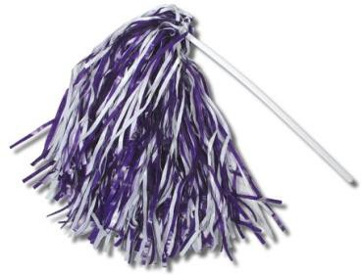 Ridge Point / Crawford 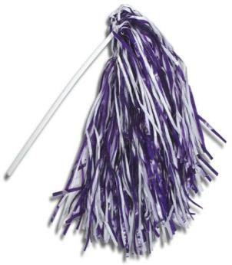



2023 *updated as of 2/17/23*

**Mandatory Parent/Candidate Meeting:**

March 21st @ 6:00 pm in the RP Gym

**Tryout Clinic @ RPHS Gym:**

March 29-31

Clinic: March 29,30 from 4:30-6:15

Mock Tryout: March 31 from 4:30 – TBD

Tryouts: April 3

Scan the code for tryout info and sign up by March 8th

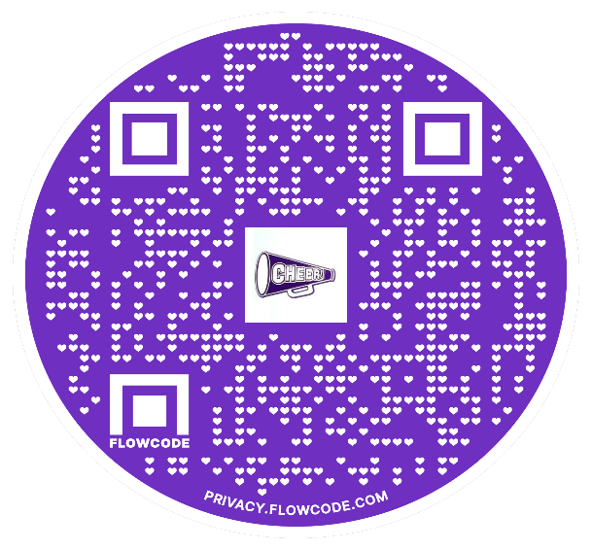

*****All forms, including physicals, are due to Coach R. Roberds by March 21st